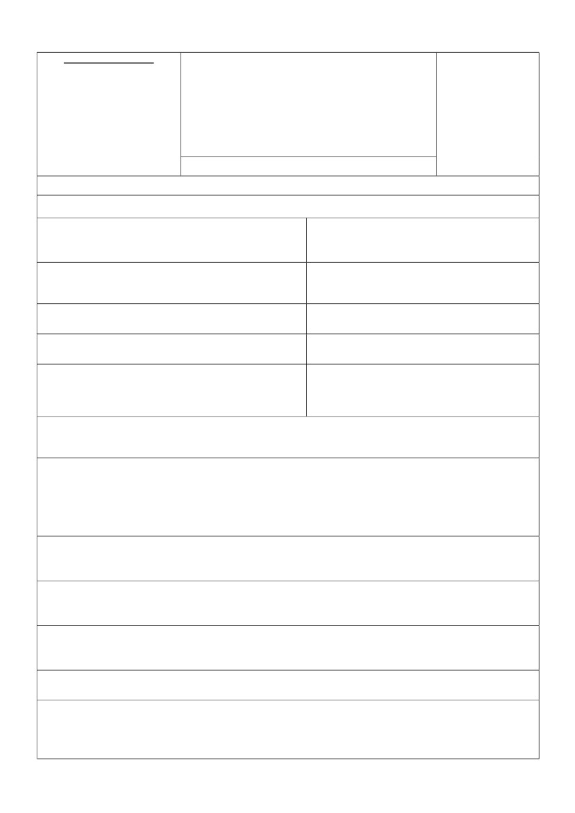
FOR OFFICIAL USE
:ﺪﯾداور هرﺎﻤﺷ
: ﺪﯾداور عﻮﻧ
: روﺪﺻ ﺦﯾرﺎﺗ
: زﻮﺠﻣ هرﺎﻤﺷ
: زﻮﺠﻣ ﺦﯾرﺎﺗ
VISA APPLICATION
ناﺮﯾا ﯽﻣﻼﺳا یرﻮﻬﻤﺟ ترﺎﻔﺳ
ﻮﻧ ﯽﻠﻫد
EMBASSY OF THE ISLAMIC REPUBLIC OF
IRAN NEW DELHI
FORM IS FREE OF COST
PHOTO
.ﺖﺳا نﺎﮕﯾار مﺮﻓ ﻦﯾا
ﺪﯾداور ﺖﺳاﻮﺧرد مﺮﻓ
COMPLETE THIS APPLICATION FROM BY PRINTING ALL OF YOUR ANSWERS
(CROSS WHERE APPROPRIATE). INCOMPLETE FORMS SHALL LIABLE TO BE REJECTED.
: ﯽﮔداﻮﻧﺎﺧ مﺎﻧ
: ﻪﻣﺎﻧرﺬﮔ هرﺎﻤﺷ و عﻮﻧ
SURNAME:
TYPE & NUMBER OF PASSPORT:
: مﺎﻧ
: ﻪﻣﺎﻧرﺬﮔ روﺪﺻ ﻞﺤﻣ و ﺦﯾرﺎﺗ
FIRST NAME:
: ﯽﻠﺒﻗ مﺎﻧ
DATE & PLACE OF ISSUE:
: ﻪﻣﺎﻧرﺬﮔ رﺎﺒﺘﻋا ﻪﻤﺗﺎﺧ ﺦﯾرﺎﺗ
FORMER NAME:
VALIDITY:
: ﯽﻠﻌﻓ ﺖﯿﻌﺑﺎﺗ
: رﺪﭘ مﺎﻧ
PRESENT NATIONALITY:
SEX : MALE
FATHER’S NAME:

FEMALE
نز
: ﺪﻟﻮﺗ ﻞﺤﻣ و ﺦﯾرﺎﺗ
FORMER NATIONALITY:
دﺮﻣ : ﺲﻨﺟ
: ﯽﻠﺒﻗ ﺖﯿﻌﺑﺎﺗ
DATE & PLACE OF BIRTH:
.دﻮﺷ ﺮﮐذ یو ﺖﯿﻌﺑﺎﺗ و ﯽﮔداﻮﻧﺎﺧ مﺎﻧ ،مﺎﻧ ،ﺮﺴﻤﻫ ﻦﺘﺷاد ترﻮﺻ رد
IF MARRIED, PLEASE GIVE THE NAME AND SURNAME
AND NATIONALITY OF YOUR SPOUSE :
ﻪﻣﺎﻧرﺬﮔ هﺪﻧراد نﺎﻫاﺮﻤﻫ ﯽﻣﺎﺳا
FAMILY MEMBERS INCLUDED IN
PASSPORT
1-
2-
3-
مﺎﻧ
NAME
ﻦﺳ
AGE
ﺲﻨﺟ
SEX
: رﺎﮐ ﻞﺤﻣ سردآ و ﻞﻐﺷ
: ﻦﻔﻠﺗ هرﺎﻤﺷ و ﻢﺋاد سردآ
OCCUPATION & EMPLOYER ADDRESS:
: ناﺮﯾا رد ﻦﻔﻠﺗ هرﺎﻤﺷ و سردآ
PERMENANT ADDRESS & TELEPHONE :
: ﺪﯾا هدﺮﮐ تﺮﻓﺎﺴﻣ ﯽﺋﺎﻫرﻮﺸﮐ ﻪﭼ ﻪﺑ نﻮﻨﮐﺎﺗ
ADDRESS & TELEPHONE IN IRAN:
ﯽﺘﺳاﻮﺧرد ﺪﯾداور عﻮﻧ
WHICH COUNTRIES HAVE YOU ALREADY VISITED:
CATEGORY OF VISA REQUESTED: ENTRY
دورو
TRANSIT
رﻮﺒﻋ
ﯽﺗرﺎﯾز / یدﺮﮕﻧﺎﻬﺟ
/

رﺎﮐ ﻖﺣ ﺎﺑ
OTHER
ﺮﮕﯾد عﻮﻧ
PILGRIMAGE/TOURIST
WORK PERMIT

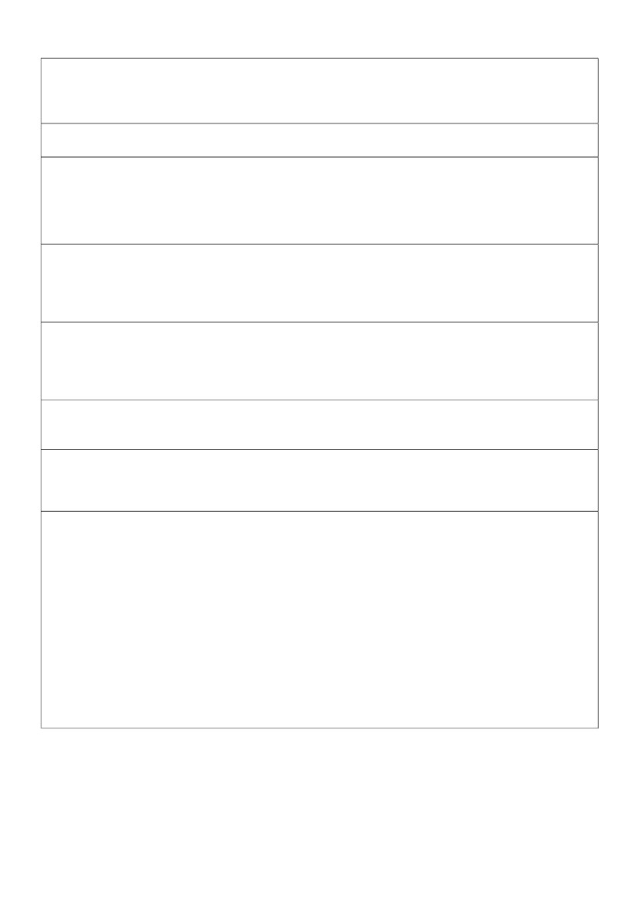
: ناﺮﯾا ﻪﺑ تﺮﻓﺎﺴﻣ زا رﻮﻈﻨﻣ
: ناﺮﯾا رد ﺖﻣﺎﻗا تﺪﻣ
PURPOSE OF VISIT TO THE ISLAMIC REPUBLIC OF IRAN:
: ناﺮﯾا ﻪﺑ تﺮﻓﺎﺴﻣ ﯽﺒﯾﺮﻘﺗ ﺦﯾرﺎﺗ
PROPOSED DURATION OF STAY IN IRAN:
: دورو عﻮﻧ

: دورو زﺮـﻣ
APPROXIMATE DATE OF ARRIVAL IN IRAN:
PORT OF ENTRY :
MODE OF ENTRY:
BY LAND BY AIR

ﯽﺋاﻮﻫ
ﯽﻨﯿﻣز
: دﻮﻤﻧ ﺪﯿﻫاﻮﺧ تﺎﻗﻼﻣ ناﺮﯾا رد ﻪﮐ ﯽﺋﺎﻬﻧﺎﻣزﺎﺳ و صﺎﺨﺷا مﺎﻧ
: ﺪﯾداور ﺬﺧا ﻞﺤﻣ و ﺦﯾرﺎﺗ ؟رﺎﺑ ﺪﻨﭼ ؟ﺪﯾا هدﻮﻤﻧ ﺮﻔﺳ ناﺮﯾا ﻪﺑ ًﻼﺒﻗ ﺎﯾآ
NAME OF THE INDIVIDUAL(S) AND ORGANIZATION (S)
YOU INTEND TO MEET IN IRAN :
: ﺖﻣﺎﻗا و ﺮﻔﺳ ﻪﻨﯾﺰﻫ ﻦﯿﻣﺄﺗ ﻞﺤﻣ
HAVE YOU EVER BEEN IN IRAN? HOW MANY TIMES? DATE AND PLACE,
FROM WHERE VISA WAS ISSUED?
؟ﯽﺨﯾرﺎﺗ ﻪﭼ رد و ﺎﺠﮐ رد ؟ ﺖﺳا هﺪﺷ ﺖﻔﻟﺎﺨﻣ ناﺮﯾا ﻪﺑ ﺮﻔﺳ ﺖﻬﺟ ﺎﻤﺷ ﺖﺳاﻮﺧرد ﺎﺑ نﻮﻨﮐﺎﺗ ﺎﯾآ
WHO WILL MEET THE EXPENSES FOR JOURNEY AND STAY IN IRAN:
.ﺪﺷﺎﺑ ﯽﻣ ﺢﯿﺤﺻ ﺐﻧﺎﺠﻨﯾا تﺎﻋﻼﻃا ﻖﺒﻃ قﻮﻓ تﺎﻋﻼﻃا ﻪﮐ دﻮﺷ ﯽﻣ ﯽﻫاﻮﮔ ﻪﻠﯿﺳﻮﻨﯾﺪﺑ
HAS YOUR VISA APPLICATION EVER BEEN REJECTED?
IF YES, PLEASE FURNISH DETAILS.
I HEREBY DECLARE THAT THE ABOVE INFORMATION IS TRUE TO THE BEST OF MY KNOWLEDGE.
.مراد ﯽﻣ ﯽﻋﺮﻣ ناﺮﯾا رد ﺖﻣﺎﻗا نﺎﻣز رد ار ﯽﺟرﺎﺧ عﺎﺒﺗا ﻪﯿﻠﮐ ﻪﺑ ﺖﺒﺴﻧ یﺮﺠﻣ تارﺮﻘﻣ و ﻦﯿﻧاﻮﻗ ﻪﯿﻠﮐ ﻪﮐ مﻮﺷ ﯽﻣ ﺪﻬﻌﺘﻣ ﻪﻠﯿﺳﻮﻨﯾﺪﺑ
DATE :
I UNDERTAKE TO OBSERVE & FOLLOW ALL LAWS AND REGULATIONS APPLICABLE TO ALL FOREIGN
NATIONALS, DURING MY STAY IN IRAN.
SIGNATURE OF THE APPLICANT:: ﯽﺿﺎﻘﺘﻣ یﺎﻀﻣا ﻞﺤﻣ

: ﺦﯾرﺎﺗ
(یروﺮﺿ سﺎﻤﺗ ﺖﻬﺟ ﺪﻨﻫ رد) ﻦﻔﻠﺗ هرﺎﻤﺷ و سردآ
ADDRESS AND PHONE (IN INDIA COMMUNICATION)

